A responsive web application to encourage home-cooking and reduce food waste

Contents

Preparation and Planning 2

Scope 2

Resources 2

Future Plan 3

Project Work 7

Information Sources 7

Project Work 8

Review and Reflection 9

Ways of Working 9

Evaluating project management 9

Legal, social, ethical and professional issues 10

References 11

Appendices 12

Appendix A 13

Appendix B 14

Appendix C 15

Appendix D 15

Appendix E 16

Appendix F 18

Appendix G 19

# Preparation and Planning

## Scope

The problem that I am aiming to solve is that of food wastage in the average household. It is estimated that each year 1.3 billion tons of food produced worldwide is wasted, wasting money for the consumer, and increasing the worldwide levels of greenhouse gases (Kirk & Scott, 2018). My solution aims to reduce waste at the consumer level, by encouraging the cooking of ingredients nearing or in some cases just passed their expiration date. It will do this by providing facilities that will enable the user to search for recipes with the ingredients that they have in their fridge that were potentially going to be discarded. The user will also be able to manage an online store cupboard where they can enter items that they would like to be included in these recipes that they may already have stored at home. There is of course a potential risk with any food that is beyond its use-by date, and so the application will also provide some information on food safety to enable the user to make safe decisions about what to eat.

The goal of the project is to deliver a responsive web application that:

* Allows searching of online recipes by ingredients which are specified by the user
* Allows viewing of method, nutritional information and ingredients for selected recipe
* Provides information on food safety
* Allows maintenance and viewing of an online store cupboard

The solution that I am proposing is that of a web-based application, that can be used on desktop or mobile devices, due to its responsive nature. I aim to build the application using a JavaScript framework, that I will research and utilise during project. The possible frameworks that I have explored are React and Vue. I have some previous experience using Angular, and so for this project I would like to gain some new skills and avoid the use of Angular if possible. I also aim to integrate with an 3rd party recipe API to provide the search feature for my application.

The scope of the project has been expanded since my last TMA to also include the implementation of a database to store the store cupboard entries. This means that I will need to implement a login feature, so entries can be stored and retrieved for a user, and the scope of the project now includes coding for the UI elements concerned with logging in, as well as user authentication and authorisation and data security activities. Data access code will also need to be written to communicate with this database, and hosting concerns will also need to be considered.

The project scope also involves the evaluation and selection of several tools that I will use throughout the project, including that of an integrated development environment (IDE) and database tools.

## Resources

The primary resource that I have started to use in my project work is the IDE VSCode.  I have selected VSCode as the tool that I will use to write the software code as it is lightweight, highly-regarded in the developer community and it provides out-of-the box support and tools for writing TypeScript (Holland, 2018), which I will be using with my selected frontend framework.  It is also the IDE suggested by the Vue.js development support team, and for this reason I feel that it is the best choice.  I considered the use of NetBeans for this project, as I have used it in previous OU modules, but the support for Typescript in NetBeans must be added via a plugin, and so for this reason I feel that VSCode is the superior choice (Hassan, 2018).  This resource is freely available for download, and therefore should be available to me whenever required, even if the hardware I am using for development fails.

Another resource that I have used is Insomnia, which is a tool for testing REST endpoints without the need to write any code.   I used this tool to test various recipe API’s and assess their suitability to use in my project (Appendix A).  An alternative product that I considered for this task was Postman, and while they both offer similar functionality, at least in terms of the functions that I require for this project, I found the Insomnia user interface easier to navigate and use to perform the tasks that I needed.  This resource is also freely available to download, and so I will be able to access whenever needed.

An additional resource that I am using during my project is the Vue.js code library, which I will use to develop the user interface for the project.  I have downloaded the source files into my project code using Node Package Manager (NPM), rather than referencing the library from the CDN, which was an alternative approach suggested by the Vue.js tutorial.  I have chosen this approach as it means I will not have to rely on the CDN being available for the application to work correctly and have removed a potential point of failure.  This choice means that I will have the resource available whenever required. As part of my project work I compared both Vue.js and React frameworks and determined that Vue.js would be the better choice for me, as the use of directives in the framework is similar to this used in Angular, which I am familiar with, and therefore there may not be such a steep learning curve for me to learn Vue.js (Stern, 2019).

Another resource that I have identified is the recipe API what I will integrate into the project to allow users to search for recipes.  Following a search engine exploration, I tested the most viable options using Insomnia, and finally settled on the use of the API provided by Edamam (Edamam, 2019).  They provide a recipe search API, where I can search by ingredient, and am provided with a list of recipes with full ingredients list and method.  This resource will be integral to the user being able to carry out the main tasks provided by the application I am building.  One requirement that I had wanted to include in the project, but am unable to due to restrictions in the available API’s, is to filter by meal type, and so the scope of the project has had to be slightly adjusted to exclude that feature.  If this were an enterprise application I would be able to use a paid-for service and access an API with this function, but for the sake of this project, I have selected the best freely available recipe API I could find.  A potential issue with this resource is that the results are provided in American measurements, and include the American names for certain ingredients, so I may have to do some work to convert them for a UK audience.  Alternative API’s that I considered were Food2Fork (Food2Fork, 2019)and BigOven (Bigoven, 2019)but discounted these because Food2Fork only provided a link to recipes with no details of them available in the response, and BigOven needed a subscription, which was not obvious before sign-up.  All other options explored were paid-for, and so not suitable for use in the application. Using a 3rd party API does mean that the resource could potentially be unavailable when needed, and I must handle such situations gracefully in the application.

To mitigate against loss of code, I have created a Git repository, where I can commit the code that I create for the project. Source control is extremely important for any web development project, and this resource is vital to ensure progress is not lost in the result of a hardware failure.

## Future Plan

The following are the outstanding tasks that are still to be completed for the project, along with their associated risks.

|  |  |  |  |  |
| --- | --- | --- | --- | --- |
| **Tasks** | **Sub-Tasks** | **Resources required** | **Skills required** | **Risk** |
| Planning and Design | Produce and evaluate wireframes | Computer based wireframing tool | Wireframing skills using chosen tool, which I have from previous module studies. | Low risk due to experience of wireframing during previous modules and familiarity with chosen tool. |
| Write acceptance tests | Usefulness to project relies on a thorough and useful set of requirements being gathered from my potential users | Skills on how to write acceptance tests will need refreshing as have not done since level 2 modules. | Carrying this task out early in the process means requirements need to remain fixed for tests to remain meaningful and useful. |
| Carry out responsive design research | Reliable learning sources in this area | Basic CSS and HTML understanding, which has been gained from previous modules. | Time concerns with learning, potential for different methods of achieving desired responsiveness may lead to research overload. Can be mitigated by keeping research as brief as possible and concentrating learning on favoured approach. |
| Recipe Search | Write HTML, CSS and JavaScript for *Recipe Search* | IDE for development | HTML, CSS and JavaScript | I may need to begin this task before I feel I have researched the new skills required thoroughly enough, due to time constraints. |
| *Recipe Search* testing | Potential users could be utilised to provide more thorough testing | Issue tracking system for bug, need to research what would be suitable. Trello could possibly be used as project tasks are already tracked here. | I have no separate testing resource other than myself, so must ensure I do not become blinkered and miss obvious issues. Could include users if possible to carry out testing to mitigate this. |
| Recipe Search refinements | IDE for development | HTML, CSS and JavaScript |  |
| *Recipe Search* API integration | Web search engine, thorough and readable documentation provided by 3rd part API provider. API testing software. | Those gathered during TM352 module | There may not exist an API that provides the information that I require for the application, or data may not be in a format that the application can easily consume. Documentation could be lacking in areas I need, or API could become unavailable for some reason. Relies on 3rd party. In this case there is not much I can do to mitigate these risks, and must hope for the best. |
| Recipe Search Results | Write HTML, CSS and JavaScript for *Recipe Search Results* | As above | As above | As above |
| *Recipe Search Results* testing |
| *Recipe Search Results* refinements |
| View Recipe | Write HTML, CSS and JavaScript for *View Recipe* |
| *View Recipe* testing |
| *View Recipe* refinements |
| Database | Research and implementation of database | Documentation for database technology chosen, potentially additional database management software | Either relational database or document-based approach will be adopted, experience of which I have from TM351, but that will need expanding upon | This was not in original scope of project, and may be a push to fit in, depending on how long it takes to decide on an approach to use and implement the scheme. |
| Write code for data access layer | IDE and documentation on desired implementation. | It should be possible to utilise existing coding skills to produce this code, but may require some research regarding the desired architecture of software components. | This is the task I feel least comfortable with and may take a while to implement. Need to use a technology compatible with Vue.js and database technology used, which will probably require additional learning and time. |
| Login | Implement user login feature | IDE, documentation on best practises, or potentially a 3rd party authentication provider such as Auth0 | Existing coding skills can be utilised, but knowledge on the area and best practises will need improving. | This task could also take a fairly long time, as it is critical to the application security and must be done properly. |
| Add Store Cupboard Item | Write HTML, CSS and JavaScript for *Add Store Cupboard Item* | As above | As above | As above |
| *Add Store Cupboard Item* Testing |
| *Add Store Cupboard Item* Refinements |
| View Store Cupboard Items | Write HTML, CSS and JavaScript for *View Store Cupboard Items* |
| *View Store Cupboard Items* Testing |
| *View Store Cupboard Items* Refinements |
| Write HTML, CSS and JavaScript for *Food Safety Index* |
| Hosting | Website and database hosting | Hosting platform | I have gained knowledge about cloud hosting from previous OU modules, but this will need refreshing | I will need to find an appropriate platform for hosting which may take time and require refreshing of the knowledge I gained in the area from previous modules. It may be difficult to do without incurring costs. |
| Testing | Acceptance Testing |  |  | Any shift in requirements will affect this task |
| Cross browser and mobile device testing | Tool that allows emulated testing across multiple browsers | Knowledge of how to operate various types of devices for testing purposes. |  |
| Module tasks | TMA01 |  |  |  |
| TMA02 |  |  |  |
| TMA03 |  |  |  |
| Final project report |  |  |  |

The potential risks associated with the upcoming tasks have been identified as follows:

|  |  |  |  |
| --- | --- | --- | --- |
| **Major Project Risks** | **Likelihood** | **Impact** | **Comments** |
| Learning a new JavaScript framework will take longer than anticipated | M | H | The functionality required for the project is not hugely sophisticated, and so basics of newly adopted framework should suffice |
| Product requirements may change | L | M |  |
| ‘Feature creep’ may occur as I begin coding and the application will become more complex than I anticipated | L | M |  |
| Hardware failure | L | L | Source code will be committed to source control, and other project files are saved to the Dropbox. Recovery should be swift if hardware fails. |
| Struggles to set up development environment | L | M | Have already achieved, with minimal issues |
| Falling behind in project schedule | H | H | Other OU module commitments have meant project has not been given full attention, but the schedule is more or less being adhered to. |
| Estimations and scheduling activities carried out for project are not accurate or achievable | L | H |  |
| Inaccessibility of chosen recipe API | L | H |  |
| Project scope becomes unmanageable | H | H | As the project continues the project scope continues to grow to include further tasks, which may mean the project is not completed. |
| Illness | L | L | There should be enough slack in the schedule to allow for days missed due to illness |

H = High, M = Medium, L = Low

A Gantt chart demonstrating the timeline for the future tasks is shown in Appendix B.

# Project Work

## Information Sources

Of the sources I identified as relevant during TMA01, I have briefly read and discounted the book ‘Front-End Reactive Architectures: Explore the Future of the Front-End using Reactive JavaScript Frameworks and Libraries’, (Mezzalira, 2018) as being useful to my project. I initially thought it may provide a comparison of various frontend frameworks, which it does, but only from the point of view of reactive programming, which is not a practise that I will be adopting for this project, due to the additional hours of project time that it will require to learn.

I still anticipate the use of ‘Jump Start Responsive Web Design’ (Word, 2017) to be useful for future tasks in the project. This book provides an in-depth view of many topics concerning responsive design, including what it is, ways in which it can be achieved and code examples of how techniques can be implemented. There are multiple chapters within the book which I envisage will be very useful for me in my research phase, and as a reference while I am implementing code. I can find little information about the author online, but other readers have reviewed the material highly, so I deem it to be a potentially very useful resource.

A main source of information that I have utilised so far during the project is the documentation available from the developers of the Vue.js source code (Vue, 2018). I can count this as a reliable source of information as it is produced by the developers who write the code for the framework and it is in their best interest to keep it relevant and up to date so that developers such as me adopt the use of the framework.

While experiencing issues during my project set-up, I used online information source Stack Overflow (Stack Overflow), which is an online information sharing website, where the developer community can ask and answer questions on various development issues. I found this an extremely valuable source of information and foresee me using it throughout the project when experiencing issues in many areas of the project, including coding, database implementation and hosting. I consider Stack Overflow a reliable source of information due to the point system that is used by the website to indicate the best quality answers. Using this tool, I can ensure I am using the highest quality answers to solve my issues.

Video content site Pluralsight has proven invaluable in my decision to use Vue.js in my project. By watching videos on both React and Vue.js I was able to determine which framework was better suited for my project. The authors of content on Pluralsight are carefully auditioned before they can post content on the website, and as such I consider this to mean content is a reliable source of information (Pluralsight.co, n.d)

## Project Work

The first task I undertook following TMA01 was to reorganise the project schedule, based on the feedback from my tutor. This was to incorporate further tasks that have been included since widening the scope of the project, and to reorganise the schedule to firstly investigate the frontend framework I will use, rather than the responsive CSS aspect of the project.

I have also made headway with finalising the requirements for the product, following an interview with a potential user of the application to gain insight into their requirements, as previously I had specified these based on my own opinions. A transcript of the interview can be seen in Appendix E, and the final list of requirements is detailed in Appendix C.

I have completed my investigation task into the which frontend framework I will adopt for the project. I did begin to create prototype applications using bother React and Vue.js to decide which I felt was more suitable, but this proved very time consuming considering it would not contribute to the final application, and so was abandoned. Instead I focussed on online material to make my decision, which was to use Vue.js.

I have also set up my development environment using VSCode (Appendix F) and created a Git repository, which I have linked to the project in VSCode (Appendix G).

I have carried out the research task for the recipe API, and have settled on a suitable one provided by Edamam, but will need to wait until I have written more of the application code before I integrate the API into the project.

Currently I am working through the tutorial provided by Vue.js, and anticipate coding on the first page of the application to begin

# Review and Reflection

## Ways of Working

One aspect of the project that I have improved on since TMA01 is the completion of my work diary, which I have been doing much more regularly and with greater detail. This has aided me greatly in reflecting on the project work so far.

Acting on feedback from TMA01, I have reorganised my project schedule (Appendix B) so that I am carrying out some tasks in tandem, and so far, I feel this has led me to be much more productive in the project. This has given me confidence that all tasks will be completed, as I have good momentum going with the project work. I also changed some tasks around after my own reflection, namely the order in which I am researching responsive design and the frontend frameworks, as I feel it would have been jumping the gun to start CSS research but have no project in which to implement the newly acquired skills.

One area that I have failed in is adhering rigidly to the schedule. I am up to date with most tasks and am on track with the task I am currently carrying out, but there are tasks earlier in the project that I am yet to finish, namely completing the creation of wireframes and producing the acceptance tests for the product. I have delayed creation of the wireframes as I do not feel well-equipped to design the mobile interfaces until I have carried out my responsive design research task, and so I have put this task off, when I would have preferred it to have been complete by now. I have delayed writing the tests as other tasks seemed more interesting, and I have been too eager to jump into coding. I must make sure I have completed this task before I begin code implementation, so that I know if what I am producing matches the requirements.

Going forward I will endeavour to stick to the schedule more rigidly, and not just move on to tasks that I feel are the most interesting or that I can complete with the greatest ease. I do however see me falling behind with upcoming commitments for OU module TM356 and a holiday, so I realise that in this situation being as strict with the schedule as possible will alleviate the workload after periods where I may not have been focussed on the project. I also work more effectively when I am feeling positive and making good progress on tasks, and so maintaining positivity is integral to me completing project work efficiently.

## Evaluating project management

Currently I am happy with the life cycle model that I have chosen to adopt for this project, which was the iterative waterfall approach, although I do feel that it has become more iterative than I had initially anticipated when first adopting this approach. Following the re-organisation of my schedule, I am working in a more iterative way earlier than I anticipated, as I am carrying out research tasks while also beginning to code, which I initially did not anticipate doing. In my mind, the iteration in the project cycle would only occur when it can to testing the application, which has proven to be the case.

I feel by adopting this more iterative approach I been able to make better progress in the actual project work as I have if I had adopted a more waterfall approach, as I would have needed to carry out all of my research tasks before beginning the first iteration of code implementation, which upon reflection has not seemed practical.

My requirements have only changed very slightly since I first defined them, and in this respect, I am also happy with the lifecycle model that I have chosen, as I have no need to keep iterating to change features for shifting requirements. With the requirements for the project as they currently stand, the schedule I have created entails one area of the application being completed before another has begun, in a waterfall style. This still seems appropriate, as I do not envisage previous areas of the application being revisited once they are completed.

## Legal, social, ethical and professional issues

A legal consideration I must make regarding this product is the storing of personal user data, for the purposes of allowing user login and user account retrieval. Without login functions currently implemented in the project yet I may not be able to consider this issue fully at this point, but must consider it carefully as I proceed through the project. At the very minimum I will need to store a user’s email address and name along with a password, which fall into the category of personal data, and therefore I must adhere to regulations set out in the General Data Protection Regulation (GDPR). A main stipulation of the GDPR is that the user must consent to personal data being stored, and this consent must be explicitly given (Allen, 2018). For this reason, I will need the user to confirm their consent for me to save their data before I do so. I must also make clear to the user the purpose for which the information is being collected as well as ensuring that the data I am collecting is stored securely, and not open to data breaches (Martinez, 2018).

I do not intend to track users of this product with the use of cookies or Google analytics tools, and so should not need to consider privacy issues with regards to these activities. That is not to say that it would not become necessary in the future to implement user tracking, at which point user privacy issues would need to be considered carefully, including what data would be collected, and allowing users to opt out of tracking.

A further issue I have had to consider during my project is that of the use of human subjects to gather requirements for the application. To ensure that I acted ethically with regard the subjects, I first gained informed consent from them, with the use of the form shown in Appendix D. This action meant that the user was informed of the data I would be collecting, how it would be stored and that they had a right to withdraw from the interview at any time. I also endeavoured to ensure that I did not lead the interview with my own opinions and allowed the interviewee to express their own views without direction.

During the project, I must consider whether it is ethical to encourage the consumption of out of date food products, and how this could potentially affect any users of the application. I would have a duty of care to my users to ensure that the application would not cause them harm in any way, and so the information that I provide on the consumption of foods past their sell-by date must be proven to be safe and correct, and endorsed by professionals. Aside from this issue, I can only foresee the impact of this product as positive, due to its main purpose of promoting eating of food that would potentially be wasted, with the aim of helping the environment. I cannot envisage a situation in which the product could be misused for nefarious purposes, or impact stakeholders negatively.

The product that I am producing could potentially be used by a variety of users, each of which could have a varying degree of ability. To this end, I need to ensure that the product I am developing is usable by as many different users as possible, and therefore that the code I am writing complies with accessibility requirements (GOV.UK) and is compliant with all the relevant coding standards.

Professional considerations that I need take in to account are that I am using only reputable 3rd party libraries and integrating with trustworthy 3rd party services. Vue.js is an open-source project that is maintained by several developers within the development community, and as such, is unlikely to be of low quality, and not follow best practises, due to the use of the pull request process when changes are made to the code (GitHub, 2019). The Vue website specifies a code of conduct that it’s contributors should adhere to, adding to the framework’s reputability (Vuejs, n.d.)

Another legal issue that I must consider is the agreement under which I am able to use the 3rd party recipe API that I will integrate into my application. To do so I must ensure that I am not using the service for any commercial or business purpose, which I am not (Developer.edamam.com., n.d.).

**Word count: 4,506**

# References

Kirk, A & Scott, P (2018) *The Guardian* [Online]. Available at <https://www.telegraph.co.uk/news/2018/01/02/no-time-leftovers-astonishing-scale-food-waste-uk-around-world/>(Accessed 28 February 2019)

Holland, B. (2018). *Visual Studio Code Can Do That? — Smashing Magazine*. [online] Smashing Magazine. Available at: https://www.smashingmagazine.com/2018/01/visual-studio-code/ [Accessed 16 Apr. 2019].

Stern, D. (2019). *Vue.js: Big Picture*. [video] Available at: https://app.pluralsight.com/player?course=vuejs-big-picture&author=daniel-stern&name=a9d0eb37-1a2c-413f-a37c-7a9ef277f353&clip=0&mode=live [Accessed 16 Mar. 2019].

Mezzalira, L. (2018) Front-End Reactive Architectures: Explore the Future of the Front-End using Reactive JavaScript Frameworks and Libraries, London, Apress

Ward, C, (2017) *Jump Start Responsive Web Design*, Victoria, SitePoint

Pluralsight.com. (n.d.). *Teach | Pluralsight*. [online] Available at: https://www.pluralsight.com/teach [Accessed 16 Apr. 2019].

Martinez, A. (2019). *GDPR compliance for web designers & developers - GoDaddy Blog*. [online] GoDaddy Blog. Available at: https://www.godaddy.com/garage/gdpr-compliance-for-web-designers-developers/ [Accessed 15 Apr. 2019].

Food2Fork. (2019). *Recipe API | Food2Fork*. [online] Available at: https://www.food2fork.com/about/api [Accessed 11 Apr. 2019].

Bigoven. (2019). *Documentation | BigOven API*. [online] Available at: http://api2.bigoven.com/web/documentation [Accessed 11 Apr. 2019].

Edamam. (2019) *Recipe Search API Documentation*. [online] Available at: https://developer.edamam.com/edamam-docs-recipe-api [Accessed 11 Apr. 2019].

Hassan, Z. (2018). *Installing and Building Environment for TypeScript on NetBeans*. [online] Developer's Diary. Available at: https://appiomatic.com/blog/installing-and-building-environment-for-typescript-on-netbeans/ [Accessed 15 Apr. 2019].

GOV.UK. *Making your service accessible: an introduction*. [online] Available at: https://www.gov.uk/service-manual/helping-people-to-use-your-service/making-your-service-accessible-an-introduction [Accessed 15 Apr. 2019].

Allen, M. (2018). *A Developer’s Guide to GDPR that won’t make you sweat*. [online] Medium. Available at: https://medium.com/ft-product-technology/a-developers-guide-to-gdpr-that-won-t-make-you-sweat-4f1f7f1d9c8b [Accessed 16 Apr. 2019].

GitHub. (2019). *vuejs/vue*. [online] Available at: https://github.com/vuejs/vue/blob/dev/.github/CONTRIBUTING.md [Accessed 16 Apr. 2019].

Vuejs.org. (n.d.). *Code of Conduct*. [online] Available at: https://vuejs.org/coc/ [Accessed 16 Apr. 2019].

Developer.edamam.com. (n.d.). Terms. [online] Available at: https://developer.edamam.com/about/terms [Accessed 16 Apr. 2019].

# Appendices

## Appendix A

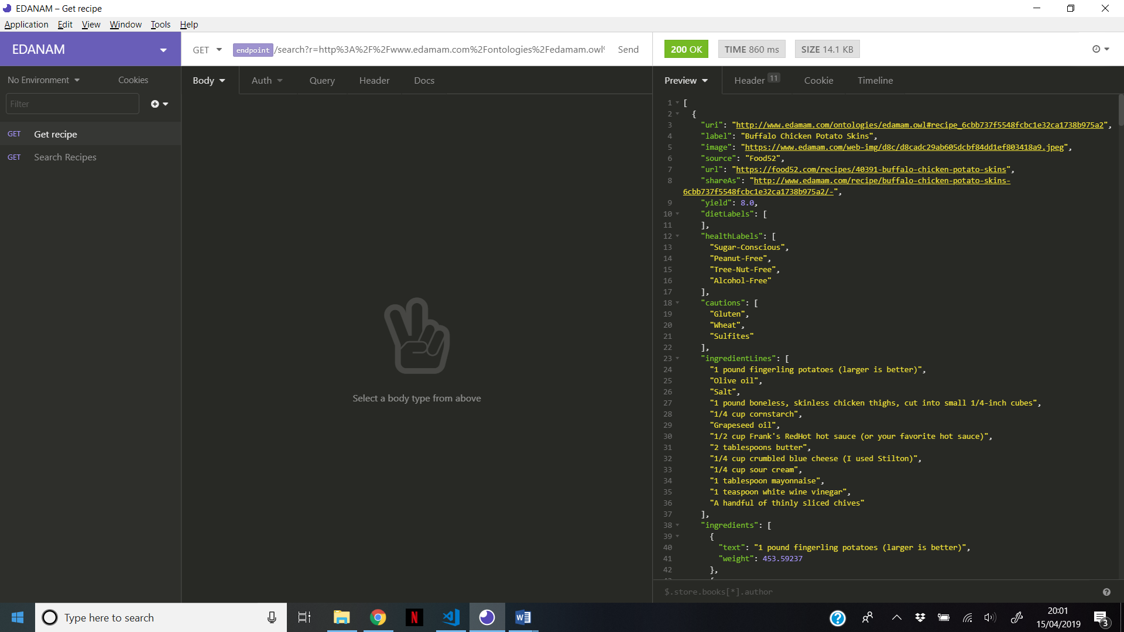

## Appendix B

## Appendix C

Updated requirements list:

The application should

1. Allow viewing of a virtual store cupboard.
2. Allow the addition of an item to a virtual store cupboard.
3. Allow the deletion of an item from a virtual store cupboard.
4. Add store cupboard ingredients to ingredients list when searching.
5. Remove an item or quantity of an item from the store cupboard once it’s been used in a recipe.
6. Allow addition of multiple ingredients to a search a recipe database.
7. Display a list of available recipes based on selected ingredients.
8. Allow sorting and filtering of recipes.
9. Show method and ingredients list of a selected recipe.
10. Provide information about food safety.
11. Allow a user to login to the application a view/edit their specific store cupboard.
12. Display recipe nutritional information to the user.

## Appendix D

TM470 Requirements Interview Consent Form

As part of TM470 project I am conducting an interview to ascertain potential requirements for an web application I will create.  Said product will be a responsive web application used to search for recipes.  The interview will focus predominantly around your use of current products of a similar nature.

The interview will take approximately 30 minutes, and you have the right to withdraw from the interview at any time.

This interview will be audio recorded, and a transcription created of this recording.  Any data collected will be used to elicit requirements that will be shared with my tutor, but the recording of the interview and transcription will not be shared with others, unless required for future assessments.

By signing this form, you confirm that you understand and agree that:

* Your data is being collected for the above-mentioned purposes.
* You may terminate the interview at any time.
* The interview will be recorded, and a transcript created.
* The data will be analysed by Sarah Redway, and not shared unless necessary for assessment purposes.
* The audio recording will be kept until September 2019 when the TM470 module ends.

**Name: __________________________________________________________________________**

**Signature: _______________________________________________________________________**

**Date: ___________________________________________________________________________**

## Appendix E

Interviewer: Hi [name]!  Just to make you aware of the rights as a participant in my interview, you have the right to terminate at any time, your data will be used by me for my EMA and a transcript included in my TMA02 document, that will be viewed by my tutor.

Interviewee: Ok.

Interviewer: First of all, do you currently use any  recipe finding applications or websites?

Interviewee: I do use websites that I find via Google, but I never stick to one.

Interviewer: So you literally just search for recipes using the search engine rather than a particular site?

Interviewee: Yeah, just because there’s never all the things that I want really on one website.  If there was one that I would say I go to most it’s probably the BBC food website

Interviewer: So when you say there’s not one that has all the things you want in one place, what are all the things you want?

Interviewee: Recipes for different meals like dinner, breakfast etc, also baking … like a little bit of everything.  You find websites for baking, but then can’t use the same for other recipes.

Interviewer: So it’s not that the interface of the application that doesn’t offer you what you want, it’s just they don’t have the recipes you want?

Interviewee: Uh-huh

Interviewer: Ok … So you literally just link through to a recipe from Google, you don’t use a search function on the websites?

Interviewee: Uh yeah, I do occasionally, it depends.  If I found a website, and I liked it, then I would use the search function on that website again, but I don’t always find one that’s useful.

Interviewer: So what features do you find useful in a recipe search, if you were to use one?

Interviewee: There is one, I can’t remember which one it is, but when you use it on a mobile it has little tabs, so you have the ingredients you need on a tab, and then you just click on the next tab at the top, then it’s got the method bullet pointed on it.

Interviewer: So that’s better for mobile view?

Interviewee: Uh-huh

Interviewer: What about when you’re actually searching?  So by ingredient, or recipe name or …

Interviewee: Um, I think sometimes it hard to search by ingredient, so I usually just search by a name, but I think if you could search by ingredients that would be more useful.

Interviewer:  Do you mean it’s hard because the website or app doesn’t do it easily

Interviewee: It just doesn’t recognise what you want

Interviewer: OK.  So if you could make yourself a recipe finder that did everything that you want, what would be the features that you would include as a priority?

Interviewee: As we were just saying, search … so you could just put in … like if you opened your cupboard and you had chicken and noodles and a few random things then you could type in what you had and then it would give you a recipe, not necessarily with everything you had, but roughly based on then ingredients that you have.

Interviewer: Cool, and what about the way it would return you your results, would you like just a list, or pictures …

Interviewee:  Definitely pictures.  I wouldn’t ever make anything if there wasn’t a picture.

Interviewer:  OK,

Interviewee:  A list with a picture is fine.

Interviewer: And you said on mobile that the tabs on that particular site are good for mobile, how about on like a normal computer monitor, would you want a different layout, or tabs,

Interviewee:  Um, if it was a computer then I’d probably go for the layout like all on one page, so you can see it all at once.  But I just think on a phone that that would be too small and you’d constantly be zooming in.  But I think if you’ve got a bigger screen and you can see it all at once then it would be a lot easier.

Interviewer: What about any friends and family?  DO you know if they use anything particular [for recipe finding], anyone got a favourite that you know of?

Interviewee:  Yeah they do use them, but I think they’re just a bit the same as me, like there’s never one that they can always find stuff on, so they just go everywhere.

Interviewer:  Cool … so in your household, what happens with food that’s going out of date, or has maybe just gone passed the sell-by date?

Interviewee:  It all gets thrown away.  We throw away so much food

Interviewer: And can you think of anything that would encourage you to not throw it away?

Interviewee:  If I knew that it was gonna go out of date, then I would use it, but sometimes it just sits in the fridge doesn’t it, you buy something and you forget it’s in there, and then you end up not using it, and it goes in the bin.  So if you knew that that was coming up then I’d definitely use it up.

Interviewer:  Cool, that’s it them, thank you so much for your participation

## Appendix F

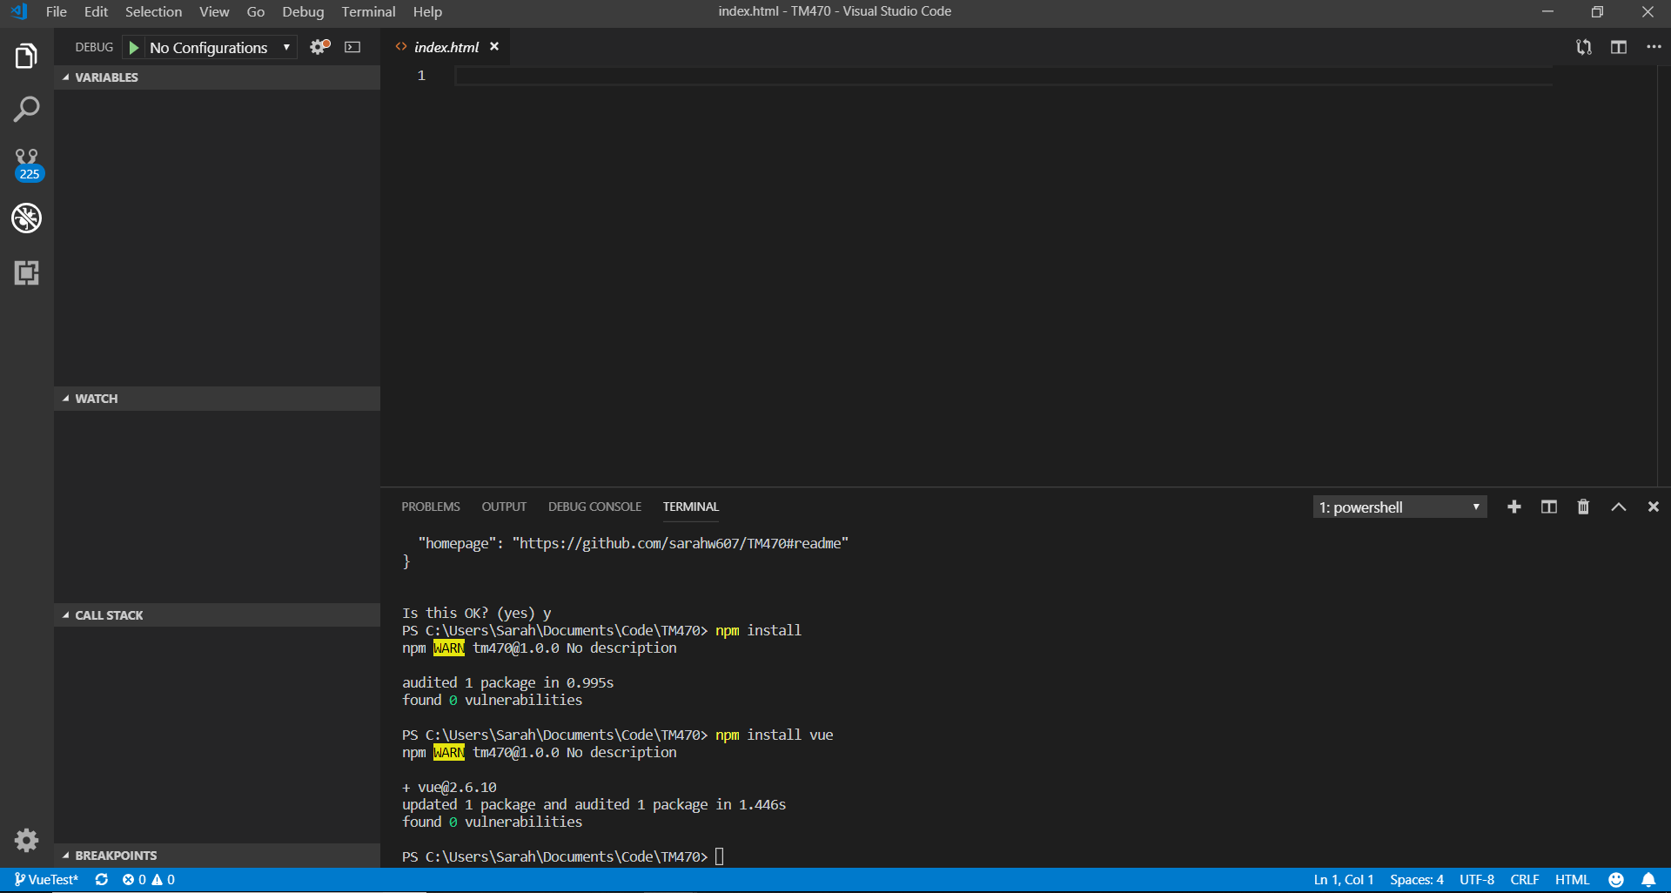

## Appendix G

